Test Plan for Assignment 2-2

Ziyang

March 8, 2020

Software: Pycharm, Postman

Environment: Python 3.7

Required python modules; pymongo, os, json, Flask

* First, open the project in Pycharm, ensure everything is properly imported.
* You may need to manually install Flask and other modules with pip. Search google for doing this.
* You may need to set project SDK (with Python 3.7). You can set it here: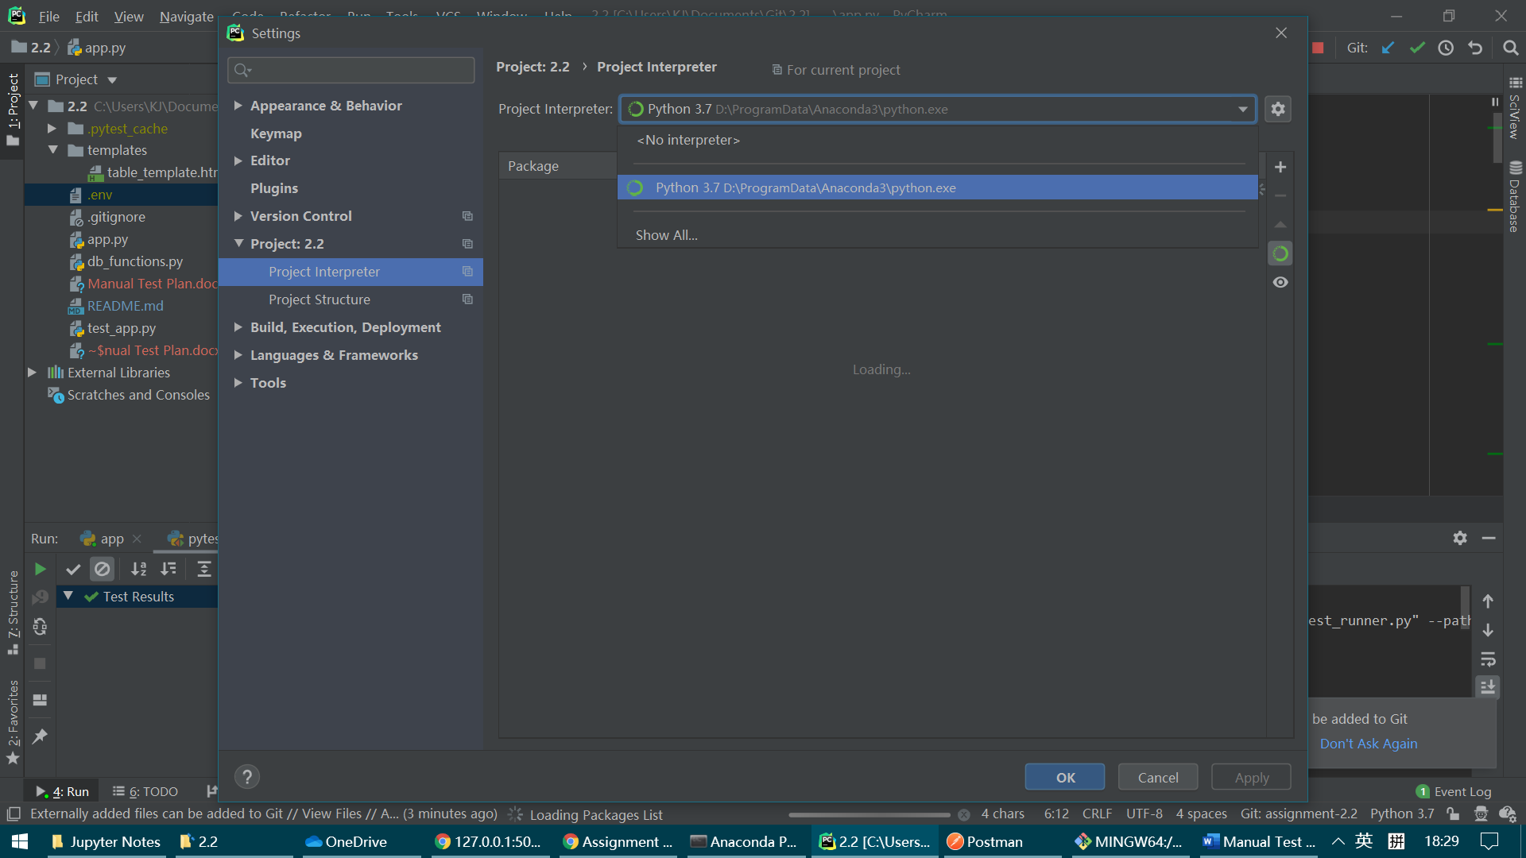
* If everything goes well, you can run app:

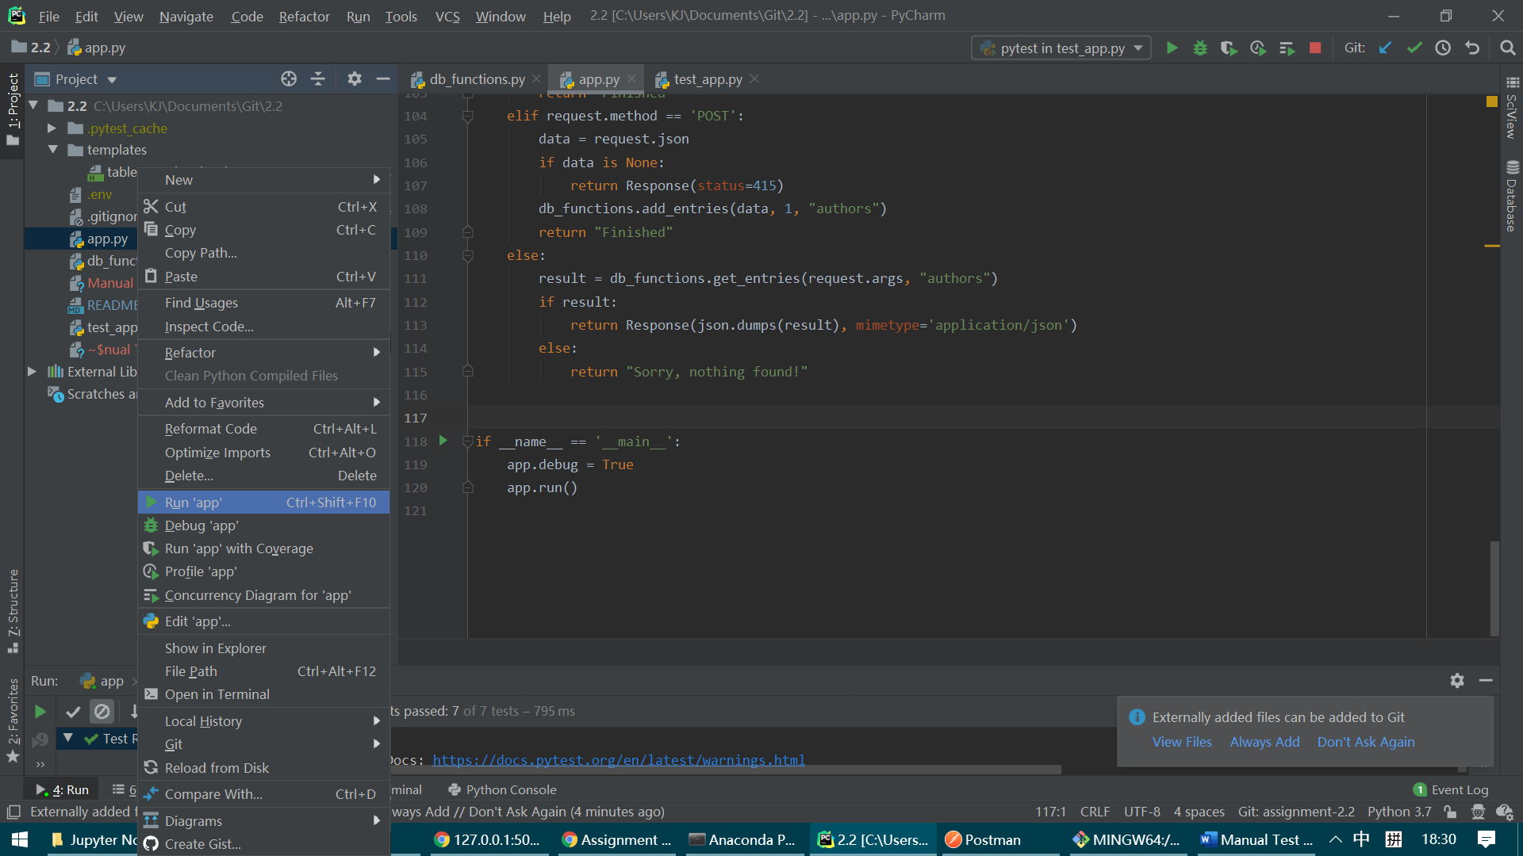

After that you should see this in console:

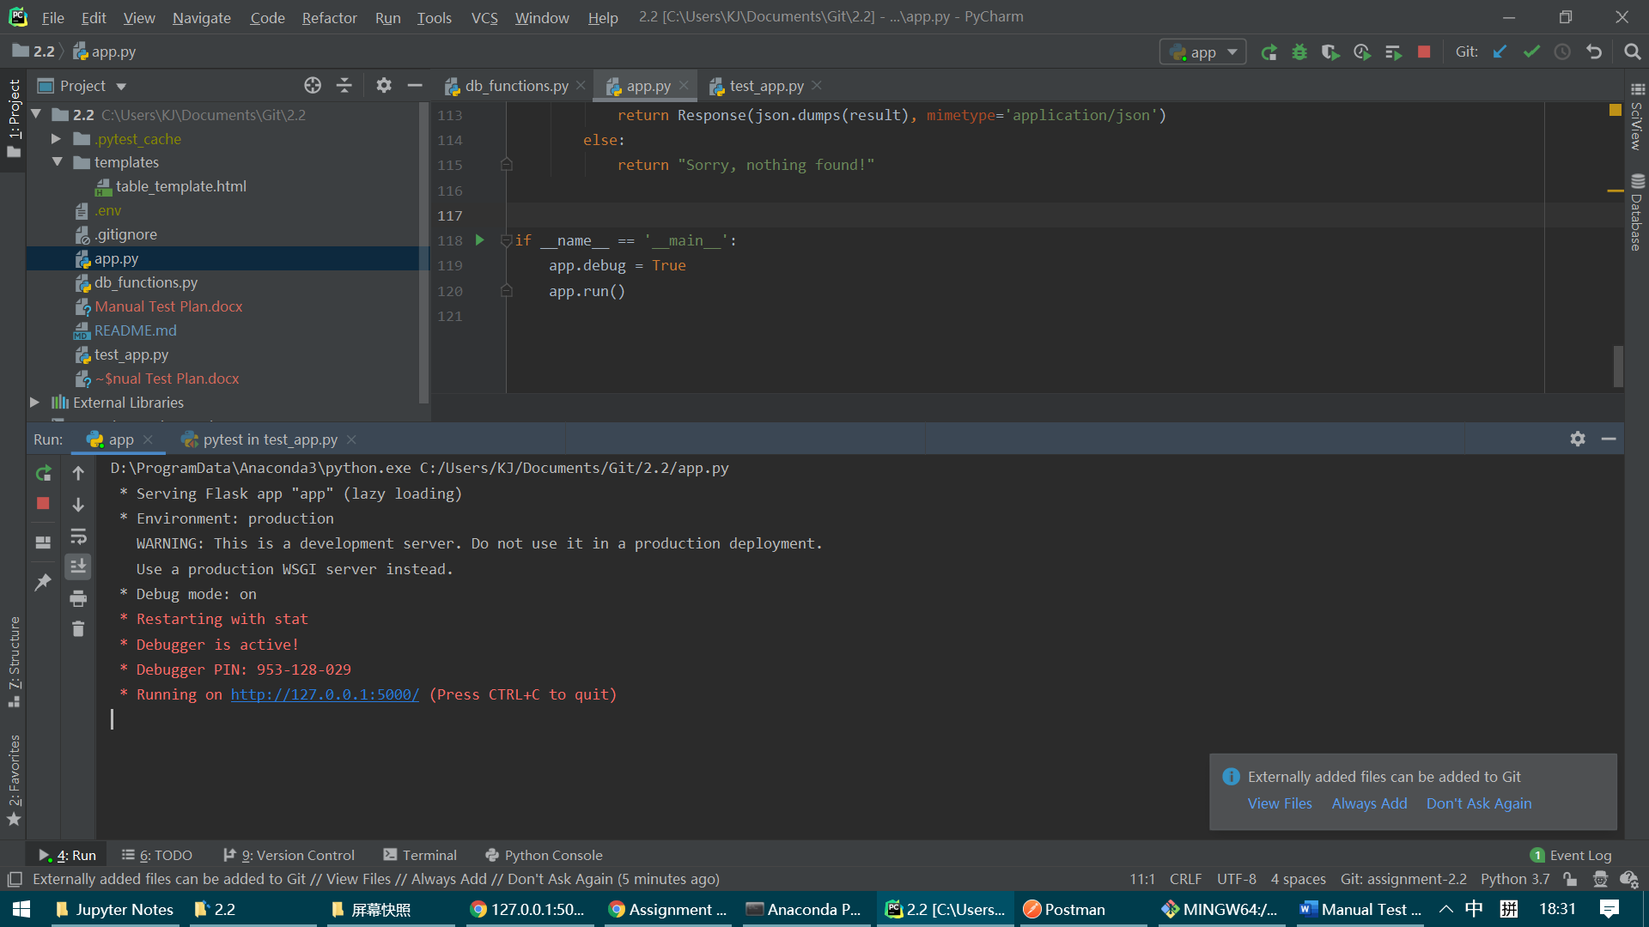

* Now, open chrome and navigate to <http://127.0.0.1:5000/>

You should see a plain text page.

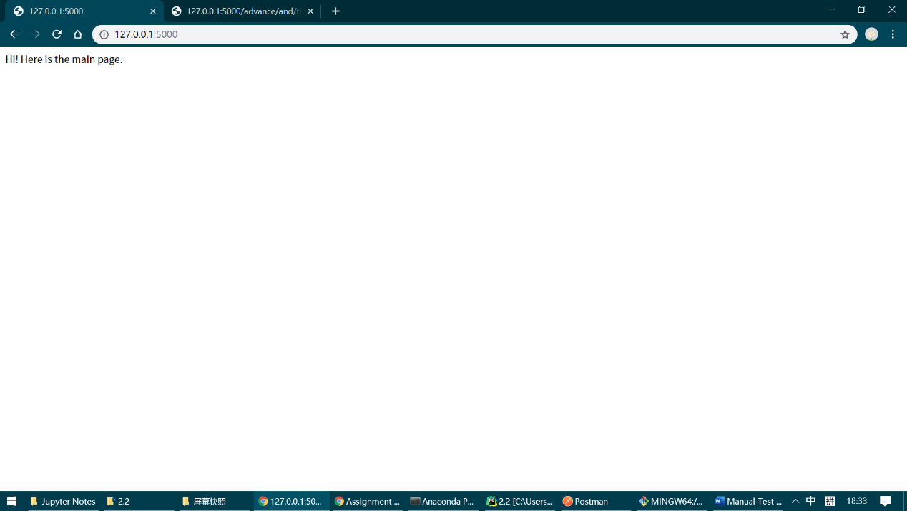

You should see same content as the following if you type the same address in address bar.

* This test basic function of GET in books & authors, and advance GET supporting AND and OR.

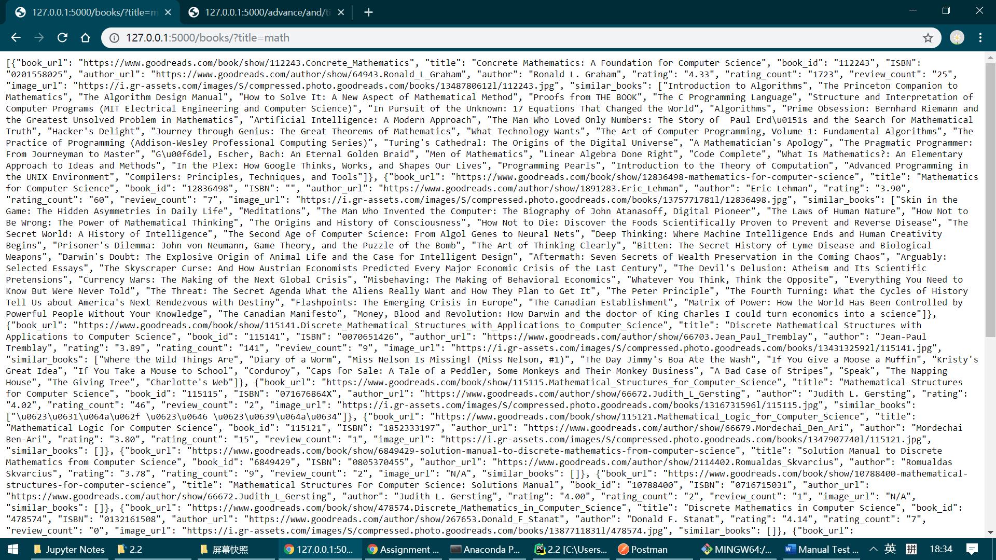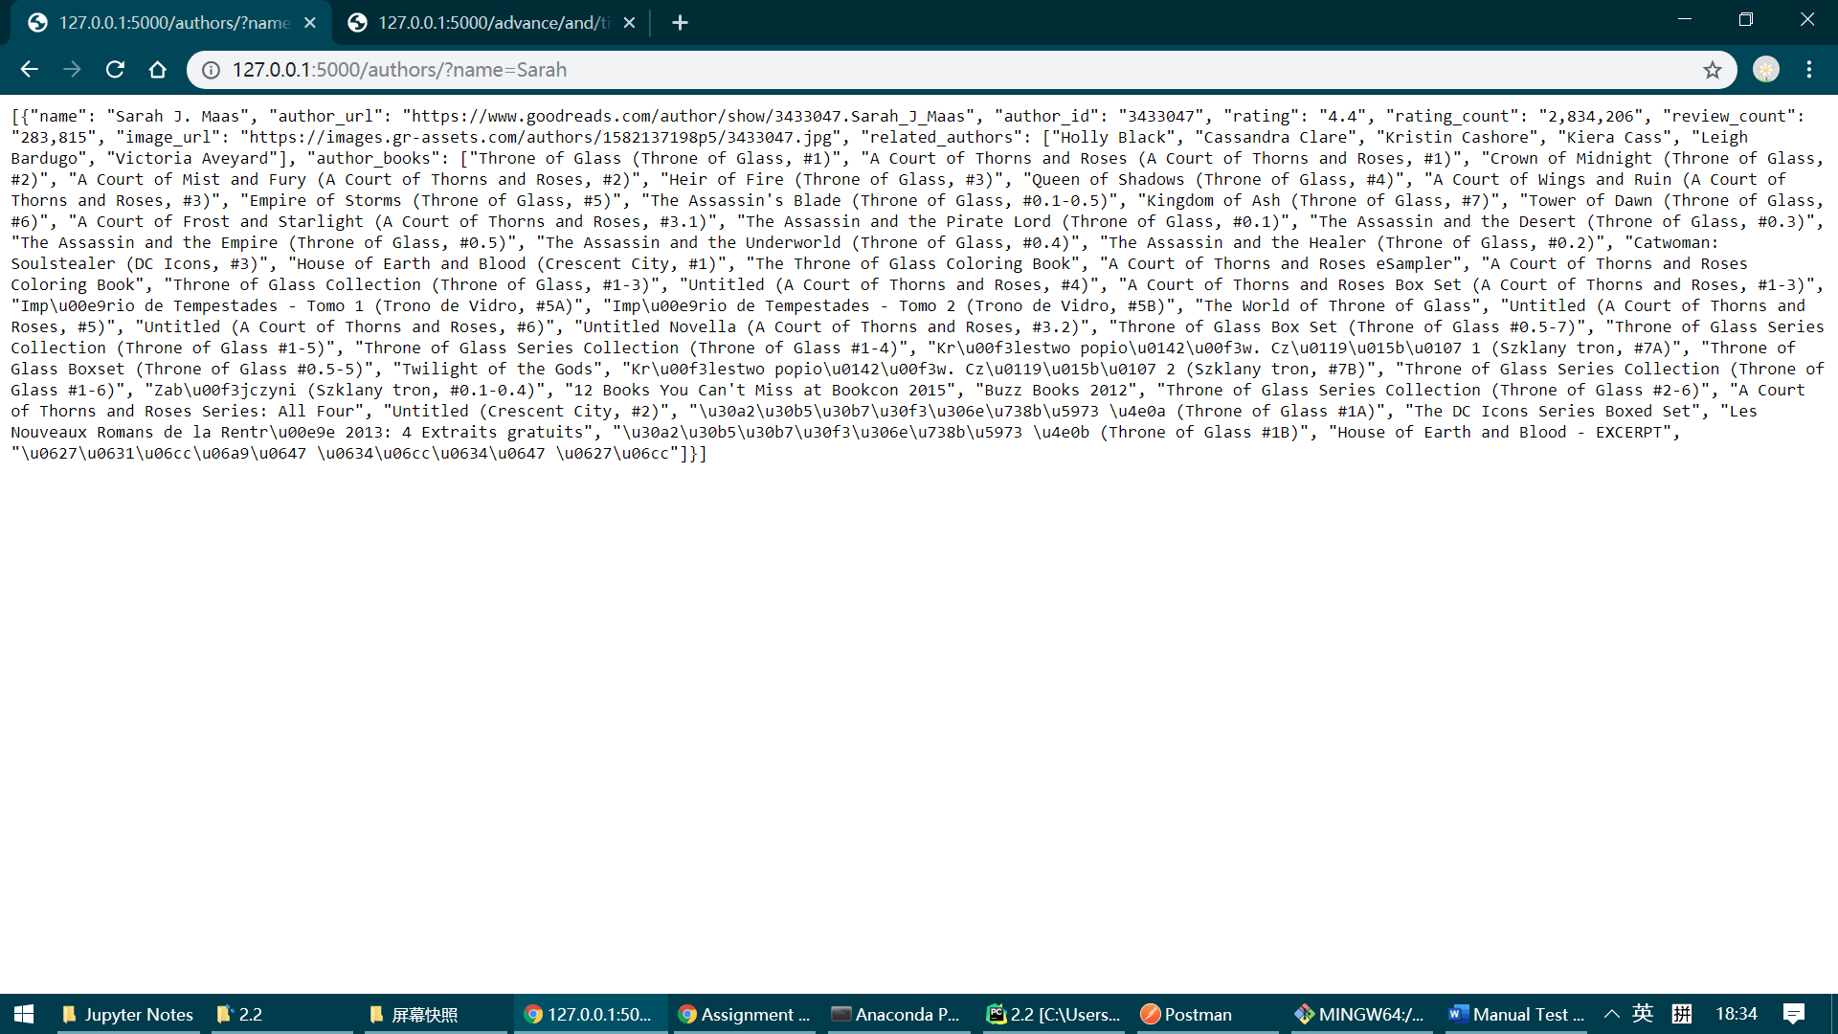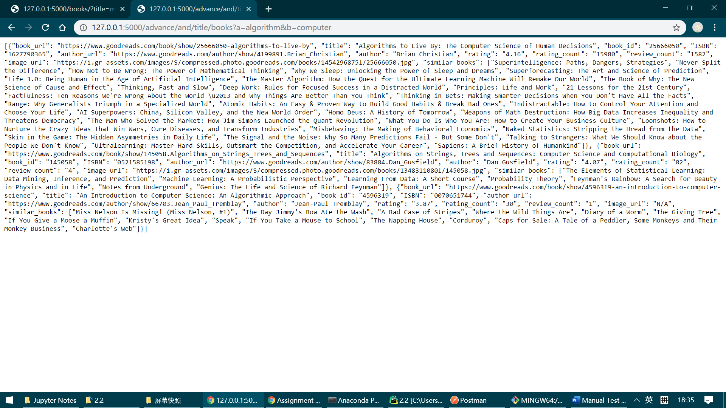

* For PUT, POST and DELETE, we need postman.

Now, open postman, you can download the software through its website and create a free account.

* Select POST on the top right choices bar, and type same thing in address bar.

At body, select RAW and JSON.

You can type anything you want in input, here is just an example.

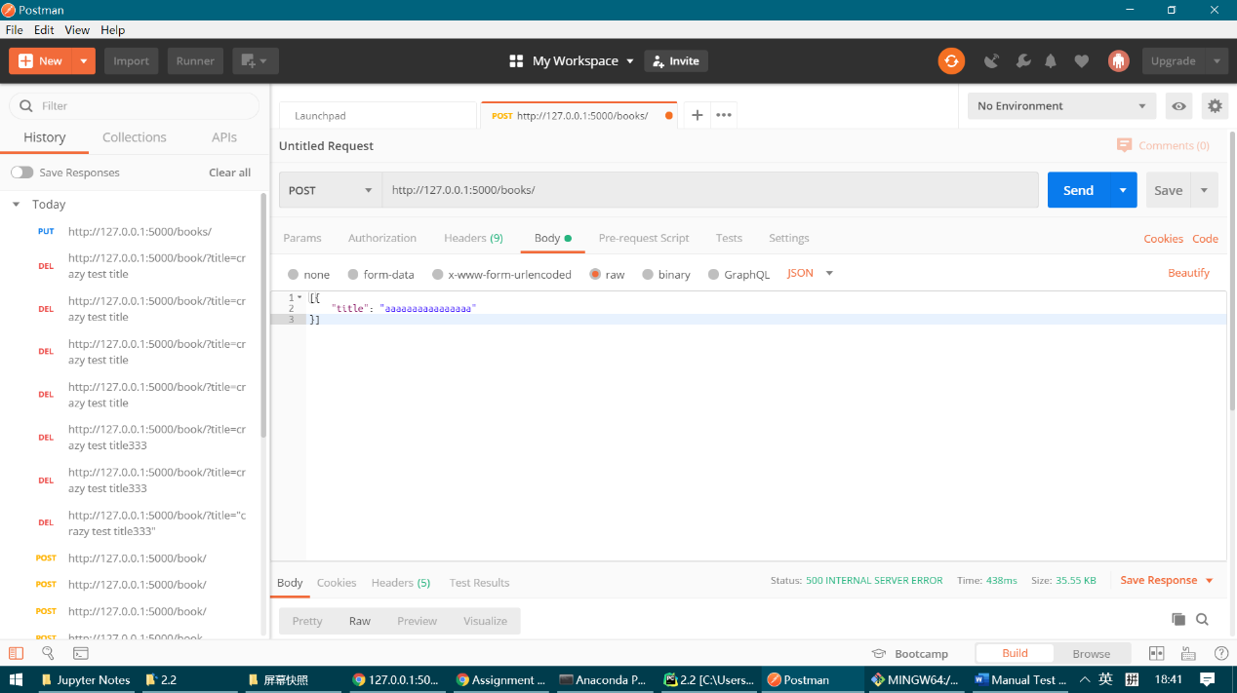

You will need to specify content header, hopefully postman has already configured this out for you. But if not, make sure same thing as below in your header part.

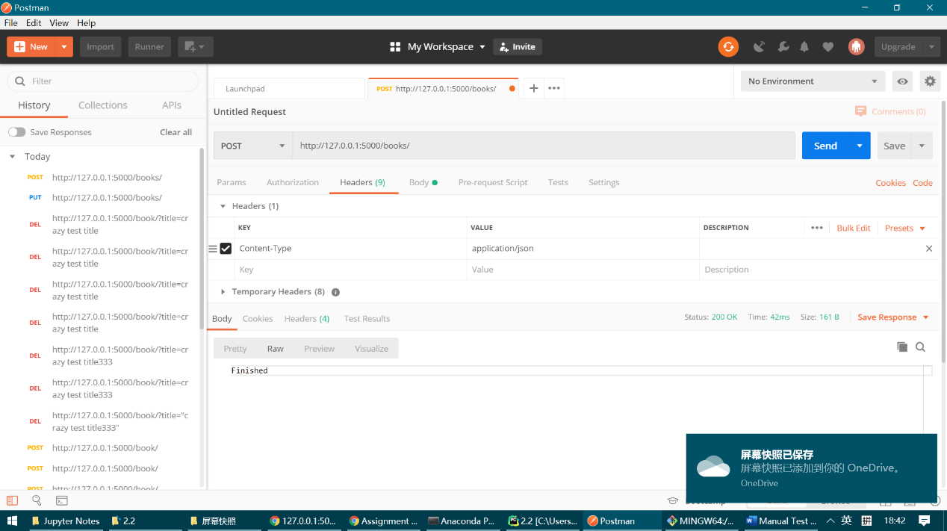

Then, click the blue send button. You should see "Finished".

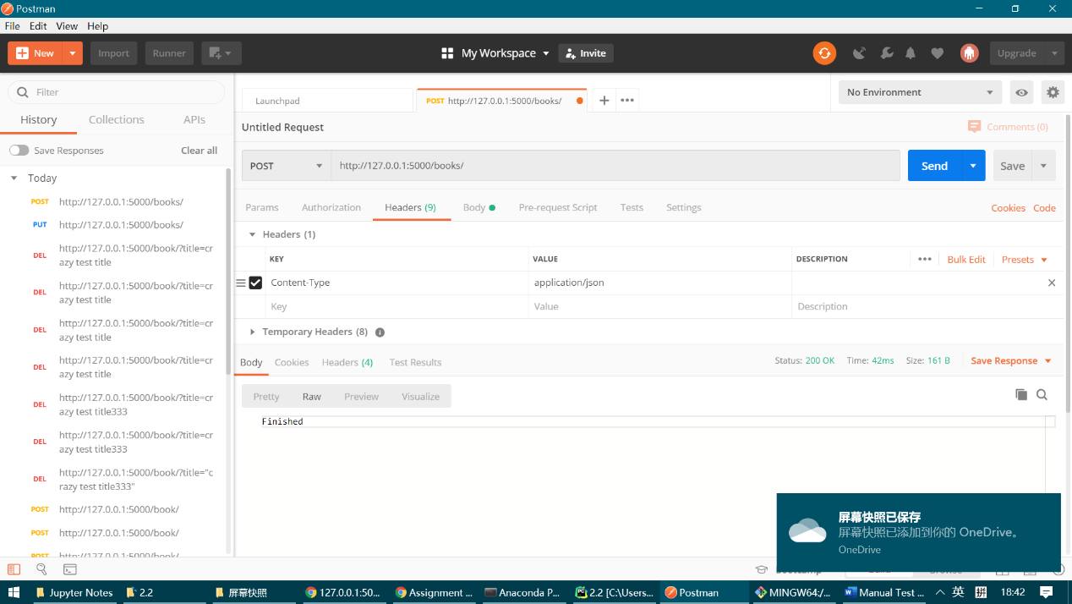

(I delete this after inserting)!

Unselect content header (make it gray) and send again. There should be an error code of 415.

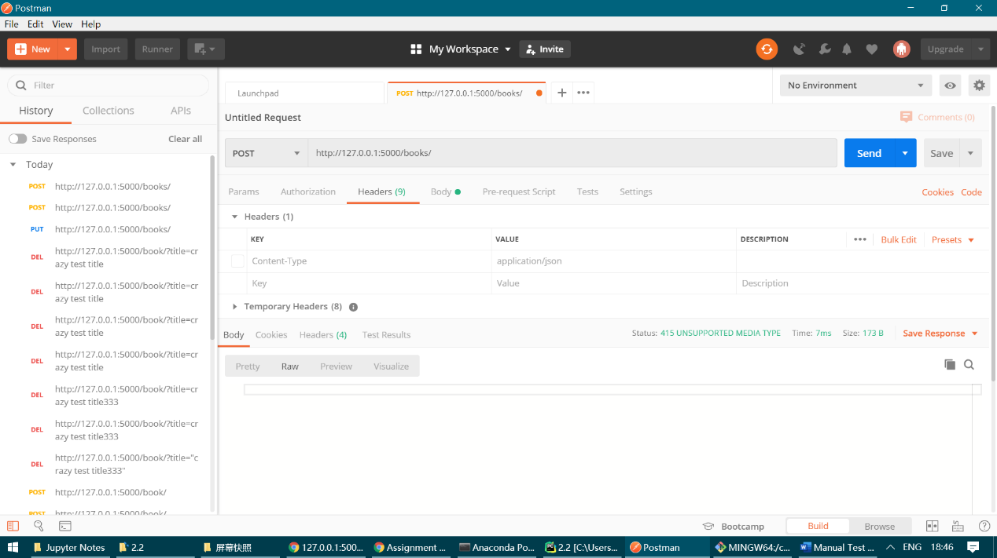

* Now it's turn for PUT! let POST a new one, like this

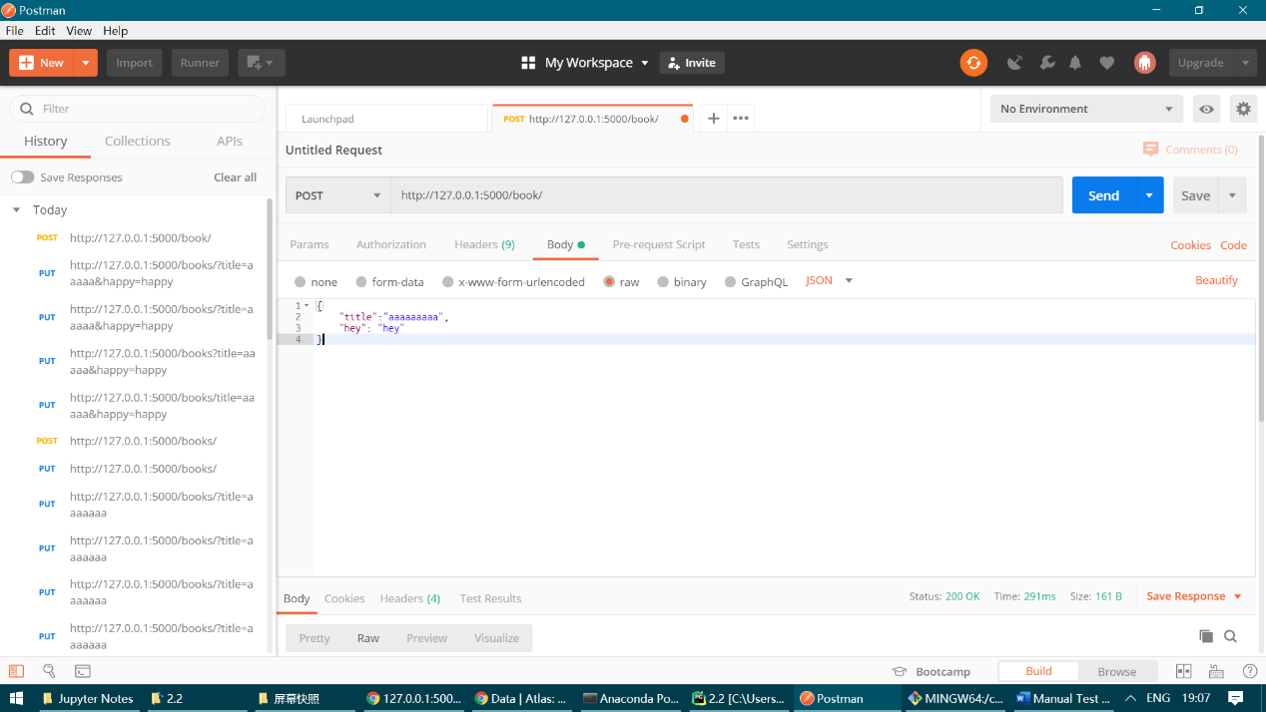

And then select PUT, type the same address and content in body as the following.

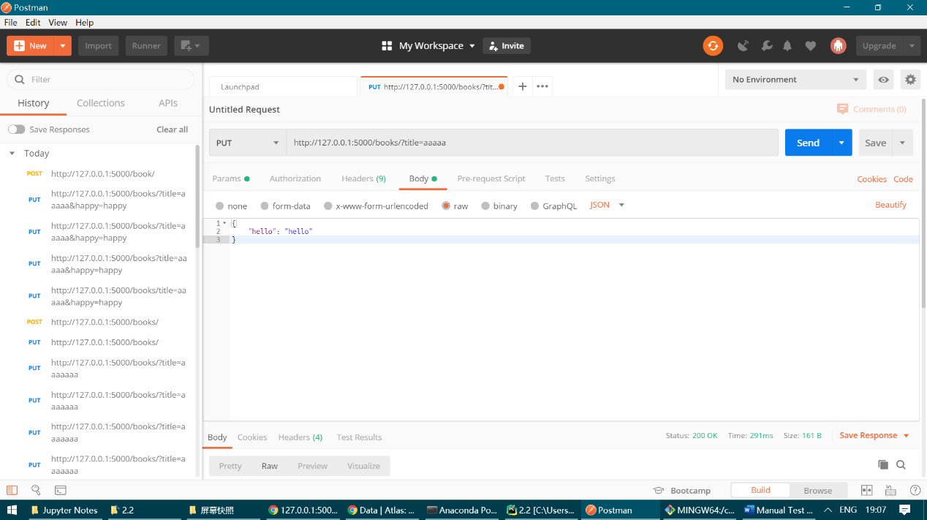

Again, you should see Finished! in returned body.

Let's check we actually get it. Open chrome again and type the follow in in address bar, you should see the same thing as in my picture.

<http://127.0.0.1:5000/books/?title=aaaaaa>

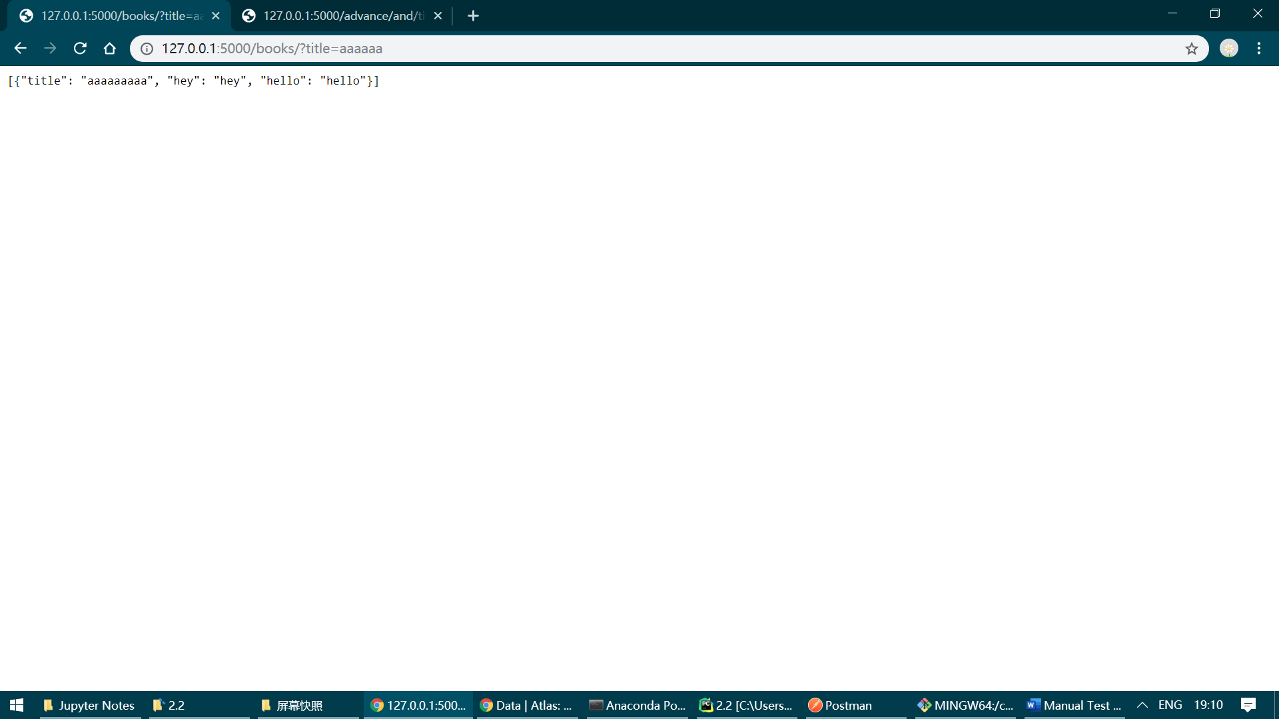

* Let's do DELETE! We may just delete the one we just updated.

Select delete and type such in address.

<http://127.0.0.1:5000/book/?title=aaaaa>

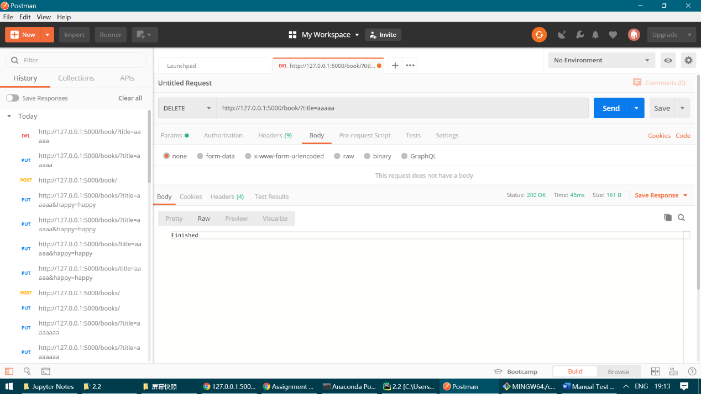

Open chrome again, and navigate to

<http://127.0.0.1:5000/books/?title=aaaaaa>

Now, it should become

